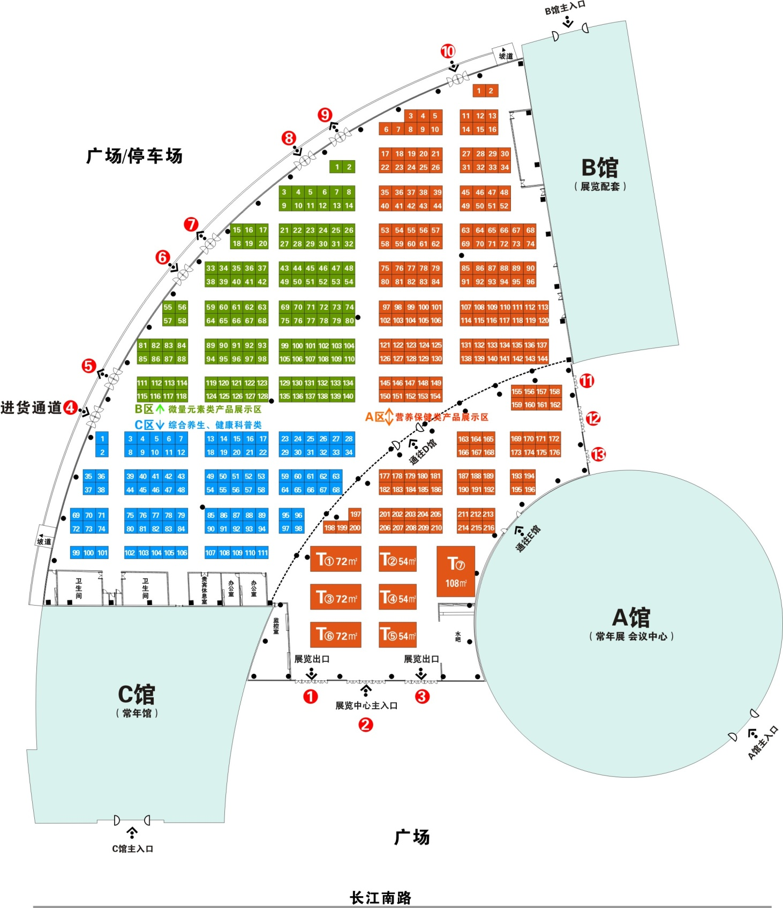 展览中心平面图Exhibition center plans

